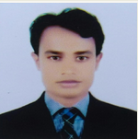
Curriculum Vitae
Of

MD.RAFIQUL ISLAM

C/O: Md. SAFIR UDDIN

Address: Village: CHAR PAKUNDIA,

P.O: PAKUNDIA

P.S: PAKUNDIAN, DIST: KISHOREGONJ

Mobile: +8801912663961
Email:mdrafiqul228@gmail.com
Career Objective:
I would like to devote all of my knowledge, skills and experience to any profession in a prosperous way where honesty, transparency and accountability would be evaluated. I could utilize the opportunity to strengthen the organization and build up my own career also.
Educational Information:
□Computer Science and Engineering
Department: Computer
Passing Year : 2015
Result : 3.40(out of 4.00)
Institute: America Bangladesh University

□Diploma in Engineering
Department: Computer Technology

Board : Bangladesh Technical Education Board
Passing Year : 2012
Result : 3.41(out of 4.00)
Institute : Kishoregonj Polytechnic Institute
□ Secondary School Certificate
Department: General Mechanics
Board : Bangladesh Technical Education Board Passing Year: 2008
Result : 4.27(out of 5.00)

Institute: Puakndia Pilot Model High School

Language Proficiency:

Bengali: Mother tongue

English: Both in speaking and writing
Computer Skill:

OPERATING SYSTEM: WINDOWS XP, 7,8,10
Office Management : MS Word, MS Excel, MS Power Point, Internet (E-mail, Browsing) Hardware & networking etc.

Personal Information:
1. Name : Md. Rafiqul Islam
2. Father’s Name : Md. Safir Uddin
3. Mother’s Name : Bedena Khatun
4. Date of Birth : 27 November, 1992
6. Religion : Muslim
7. Sex : Male
8. Marital Status : married
09. Blood Group : A (+)
10. Height : 5’5”
11 National ID : 19924827902000012
12. Weight : 54kg

Contact Information:

1. Contact Address : Village: Char Pakundia P.O: Pakundia
P.S:Pakundia,Dist: Kishoregonj

2. Mobile : +8801912663961
3. Email : mdrafiqul228@gmil.com

Experience:
1. Junior instructor (computer) at Pakundia Polytechnic Institute
(01.07.2014 to 30.12.2014)
2. TA (ICT). (20.01.2015 to Till Now.)
BRAC Education Programme

Declaration:

I do thereby declare that the particulars provided here are true and no Misinformation is given

Signature & Date
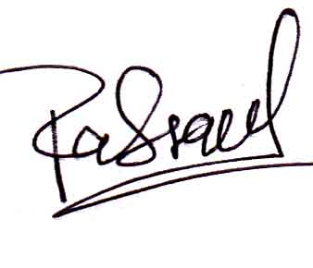 ………22/05/2017………….
(Md. Rafiqul Islam)

